**Hotel Guest Management System**

By Samson Tulu

109291

CS-425 Software Engineering

Senior Project

Professor Obina Kalu

Advisor Dr. Ann Dow

June 2020

In partial fulfillment of the requirement for Bs in Computer Science

**Project GitHub link:**

[**https://github.com/SamTulu/Hotel-Guest-Management-System.git**](https://github.com/SamTulu/Hotel-Guest-Management-System.git)

**Abstract**

The system aims to maintain and manage the different Hotels that are

available in the different parts of the world. It mainly takes care of the Hotel reservation system. The system provides information regarding the different Hotel room types that

are available and their status specific to availability. The guests can visit the site and register

themselves with the required information that is expected by the system. Each registered guest

can raise a request for the unit reservations. The Guests are scheduled with the information on the units' availability, for they have requested the time.

The total front end was dominated using HTML standards applied with the dynamism of

Thymeleaf pages. At all proper levels, high care was taken to check that the system manages the data consistency with proper business validations. The database connectivity was planned using MySQL relational database management system, the authorization, and authentication were cross-checked at all stages. The user-level accessibility has been restricted into three zones the administrative, staff/receptionist and the average user/client zone.

1. **Introduction**

Hotel Guest Management System (H.G.M.S) is a fully functioning web-based multi-platform where users can remotely create, update, and cancel the reservation online. furthermore, this application is designed to manage tasks as adding a guest or creating a guest member, search room availability, manage room information, check-in and check-out, and payment functionality. The user interface of this web-app is developed using technologies like JSP and Thymeleaf. The back-end is developed using the Spring framework technologies like spring mvc, spring boot, JPA , and Hibernate integrating with SQL database. This project is designed with a domain-driven design using an agile software development process. The implementation for the H.G.M.S. is going to be handled through an Object-oriented approach. Based on these methodologies, the project work is expected to be light and fully functional. Several testing mechanisms evaluate the system regarding the functionality and user levels of the developed system—the evaluation results for further preservation and enhancement of the product. Thoroughly operative Hotel Guest Management System performs the highest aspirations and all the events of the hotel. The Software Requirements Specification (S.R.S.) will provide a detailed description of the requirements for the Hotel Guest Management System (H.G.M.S.). This S.R.S. will allow for a complete understanding of what is to be expected from the newly introduced system, which is to be constructed. A clear understanding of the system and functionality will allow for the correct software to be developed for the end-user.

**2. Positioning**

**2.1 Problem Statement**

|  |  |
| --- | --- |
| The problem of | * Going in person to the hotel in regards of checking room or hall availability and price * Managing guest reservation * Time management * Low customer attraction * No suitable way of communicating with guests |
| Affects | The Hotel and Guests |
| the impact of which is | * Low cash flow of the hotel * customer unsatisfaction * inconvenience |
| a successful solution would be | * Eliminate any inconvenience in regard to reservations * Provide an easy access to make reservations Eliminate time wastage * Reduces human intervention to make reservations |

**2.2 Product Position Statement**

|  |  |
| --- | --- |
| For | Everyone |
| Who | Need to reserve a hotel room or hall |
| The (product name) | HGMS (Hotel Guest Management System) |
| That | Provide an easy access and convenient way for each guest to make reservations and check availability |
| Unlike | Other hotels that require human intervention for reservations |
| Our product | Will let the guest to become a member in order to build up their tier status for future discounts |

**3. Stakeholder Descriptions**

**3.1 Stakeholder Summary**

|  |  |  |
| --- | --- | --- |
| **Name** | **Description** | **Responsibilities** |
| Owner | Owner can monitor and authorize the task handle by the system and set daily rate, add, delete, update, view staff and user information. | Admin are responsible for setting up, insert initial data and managing system. |
| Receptionist | Receptionist can check-in , check-out , modify , upgrade , issue payment for guests. | Receptionists are responsible for managing guest experience. |
| Guest | Guests can make reservations, check availability, check-in ,issue payment, modify stay . | Guests are responsible for filling out the required information |
| Developer | Developers developer system on the basis of given document. | Developers are responsible for developing system features, fixing bus, and maintaining the system’s availability. |
| Tester | Testers use JUnit tool to test system or integration test | Testers are responsible for integration testing. |

**3.2 User Environment**

The user has access to online through the web application provided by the Hotel. Through this web app, the user can view available rooms and hall, make reservations, check-in, issue payment. This application can be accessed through a web browser from a mobile phone, tablet or a computer with any operating system.

**4. Product Overview**

**4.1 Product Perspective**

The product is independent and totally self-contained

**4.2 Assumptions and Dependencies**

There are no factors that affect the features stated in the vision document.

**4.3 Needs and Features**

|  |  |  |  |
| --- | --- | --- | --- |
| **No** | **Problem** | **Need** | **Features** |
|  | | | |
| 1 | Making reservations require directly going to the hotel in person | Customer needs to provide necessary personal information | The hotel management system allows customers to make reservations online |
| 2 | Checking room availability and making reservations online | Rooms and halls need to be updated when reserved | Only available rooms will be displayed for reservations. Reserved rooms will be hidden by the application during search. |
| 3 | Getting discounts by frequently staying at the hotel | Customer needs to have an account to keep track of points | The system keeps track of customer guest stays to update points for future reservation discounts |

**4.4 Alternatives and Competition**

An alternative will be to use external booking websites to handle reservations. Although this is an alternative, it will cost the hotel additional fees that are paid to an external provider which can be avoided by having this hotel management system.

**5. Other Product Requirements**

Web Server

Intel Xeon-D 1541 8 core/16 thread 2.10GHz speed/core 1TB SSD 16GB RAM

Internet Access

MySQL Database System

**6. Diagrams and Specifications**

6.1 System Architecture Diagram

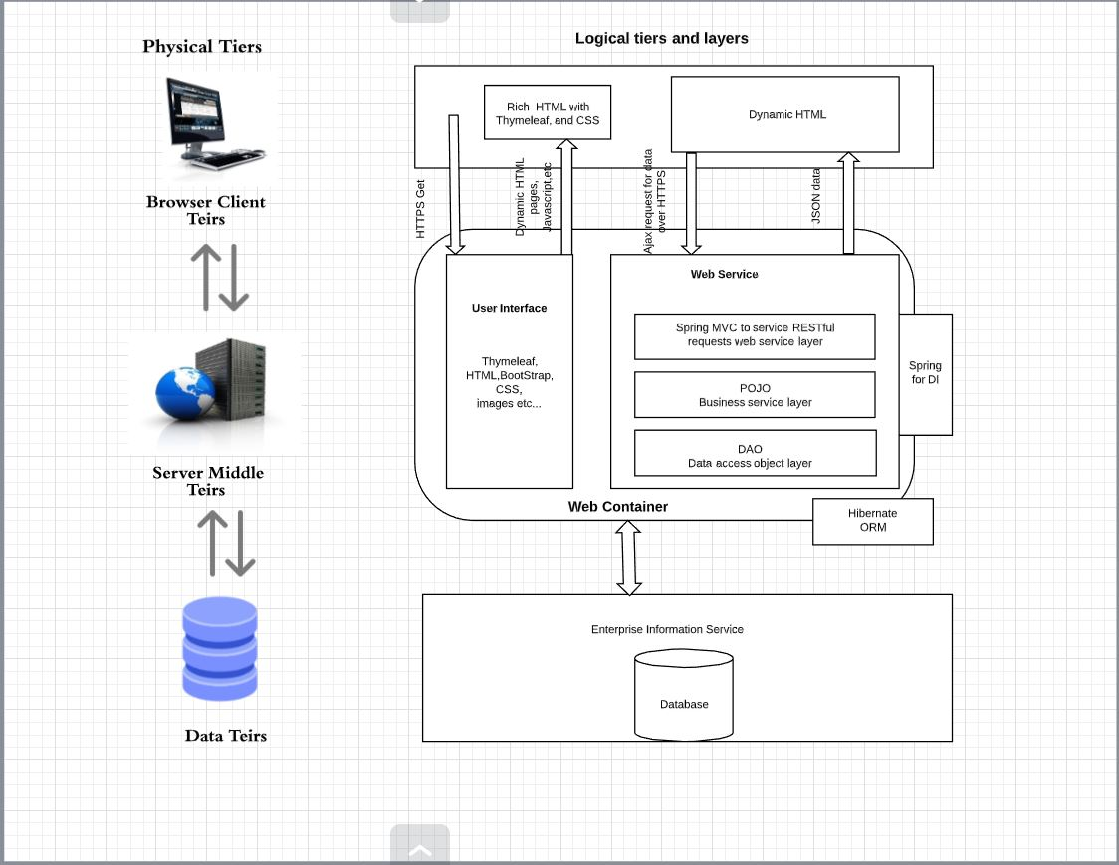

6.2 Use Case Diagram

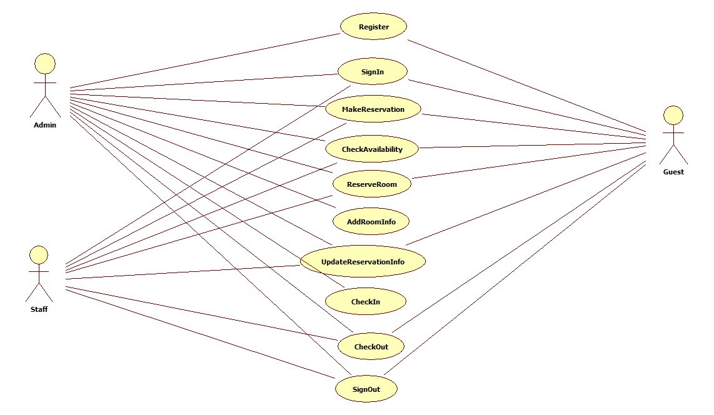

6.3 Domain Class Diagram

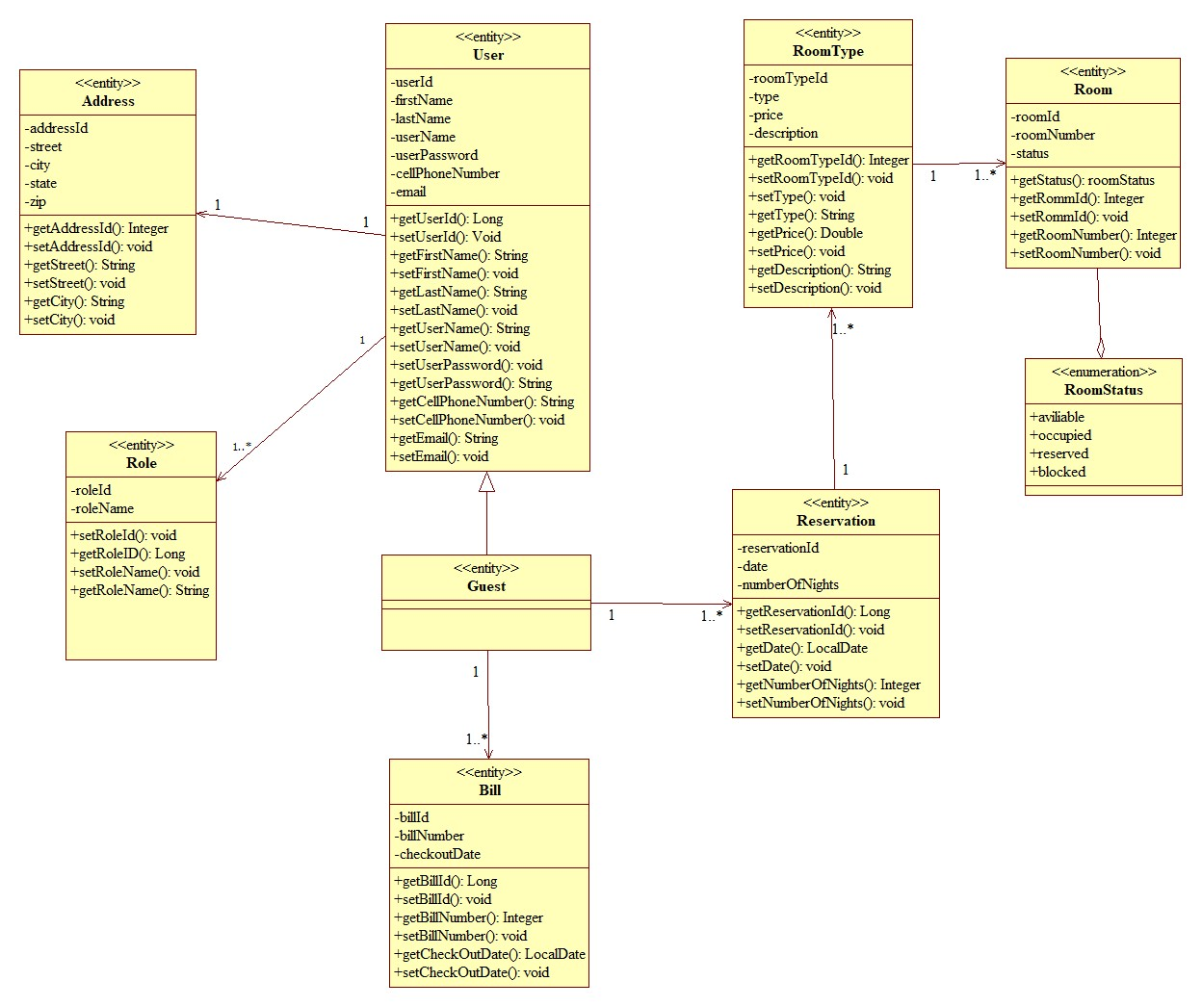

6.4 Main Use Case VOPC Diagram

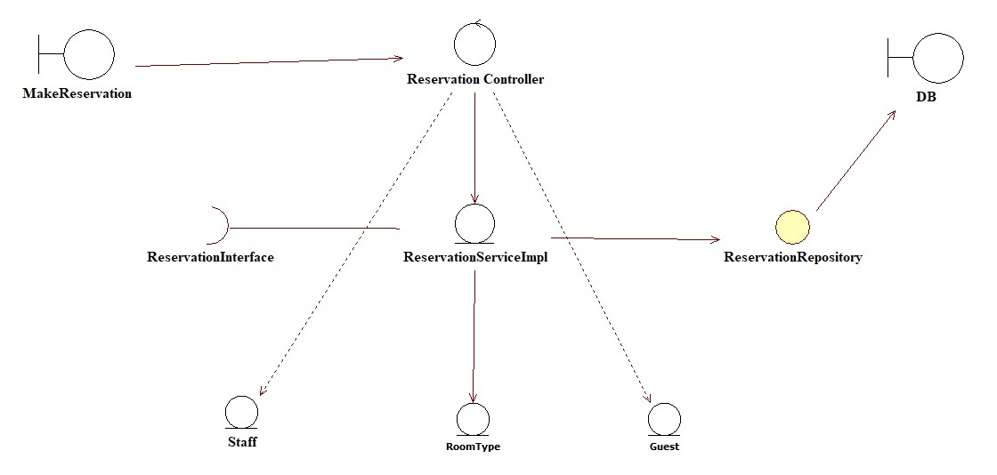

6.5 Main Use case sequence Diagram

6 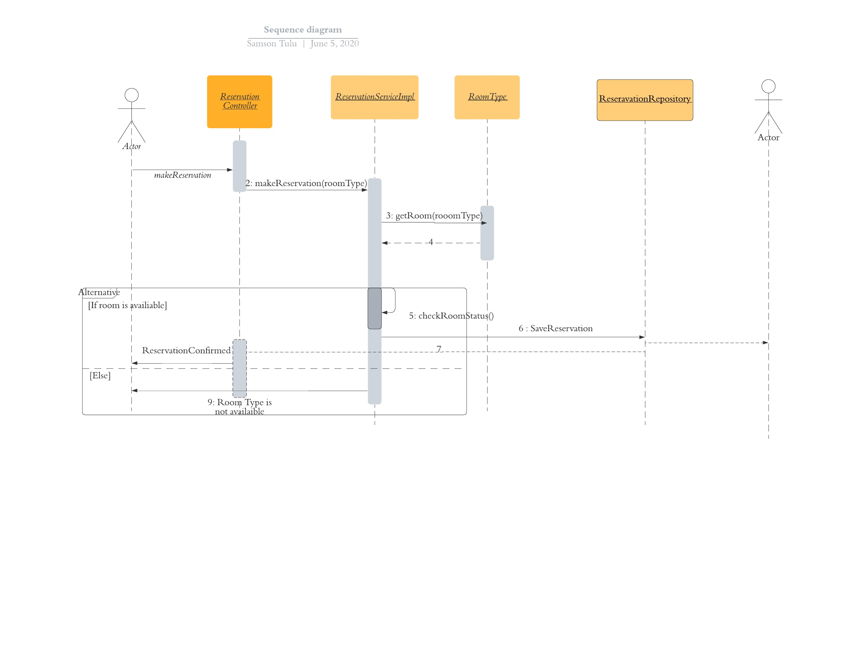

6.6 ER -Diagram

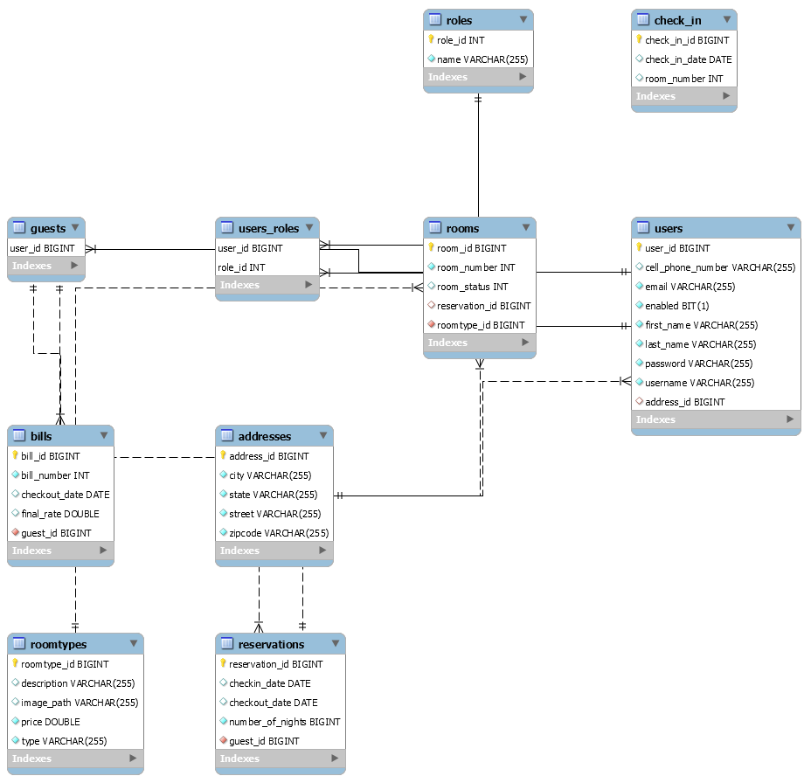

6.7 User Interface

6.7.1 Home Page

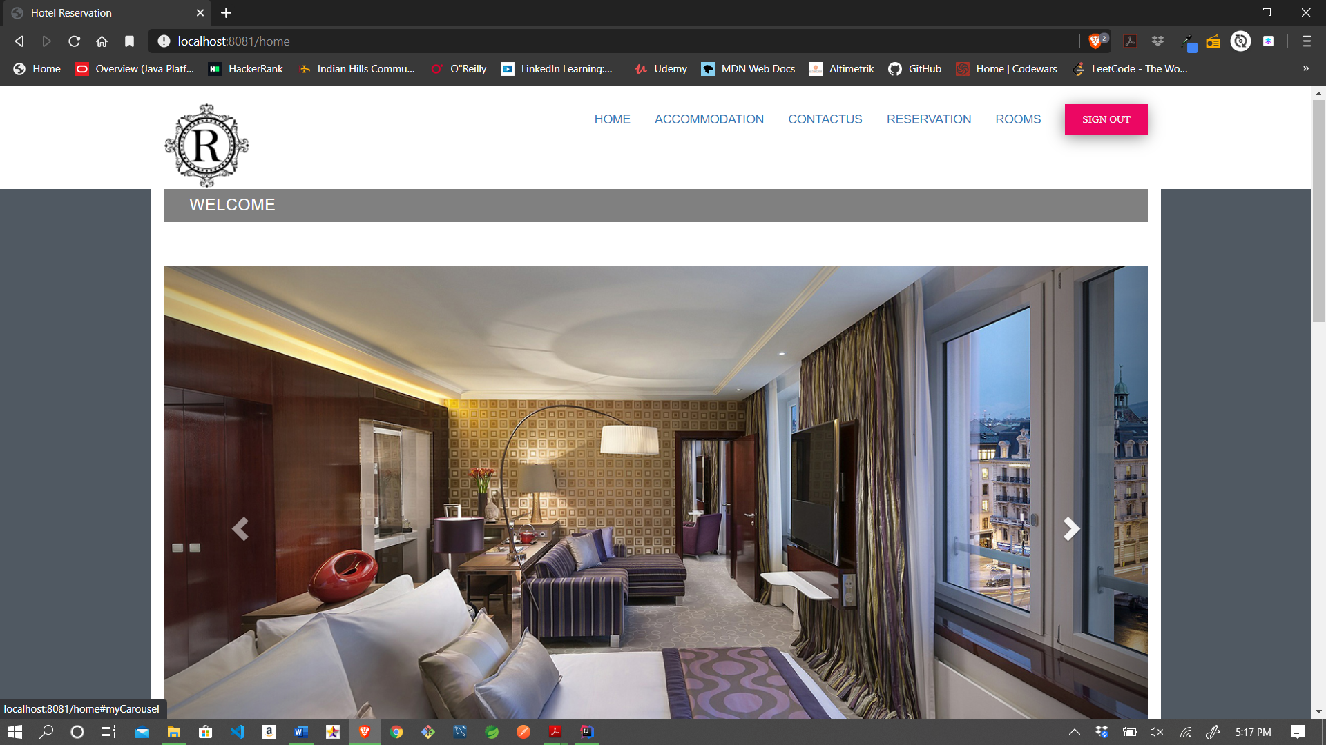

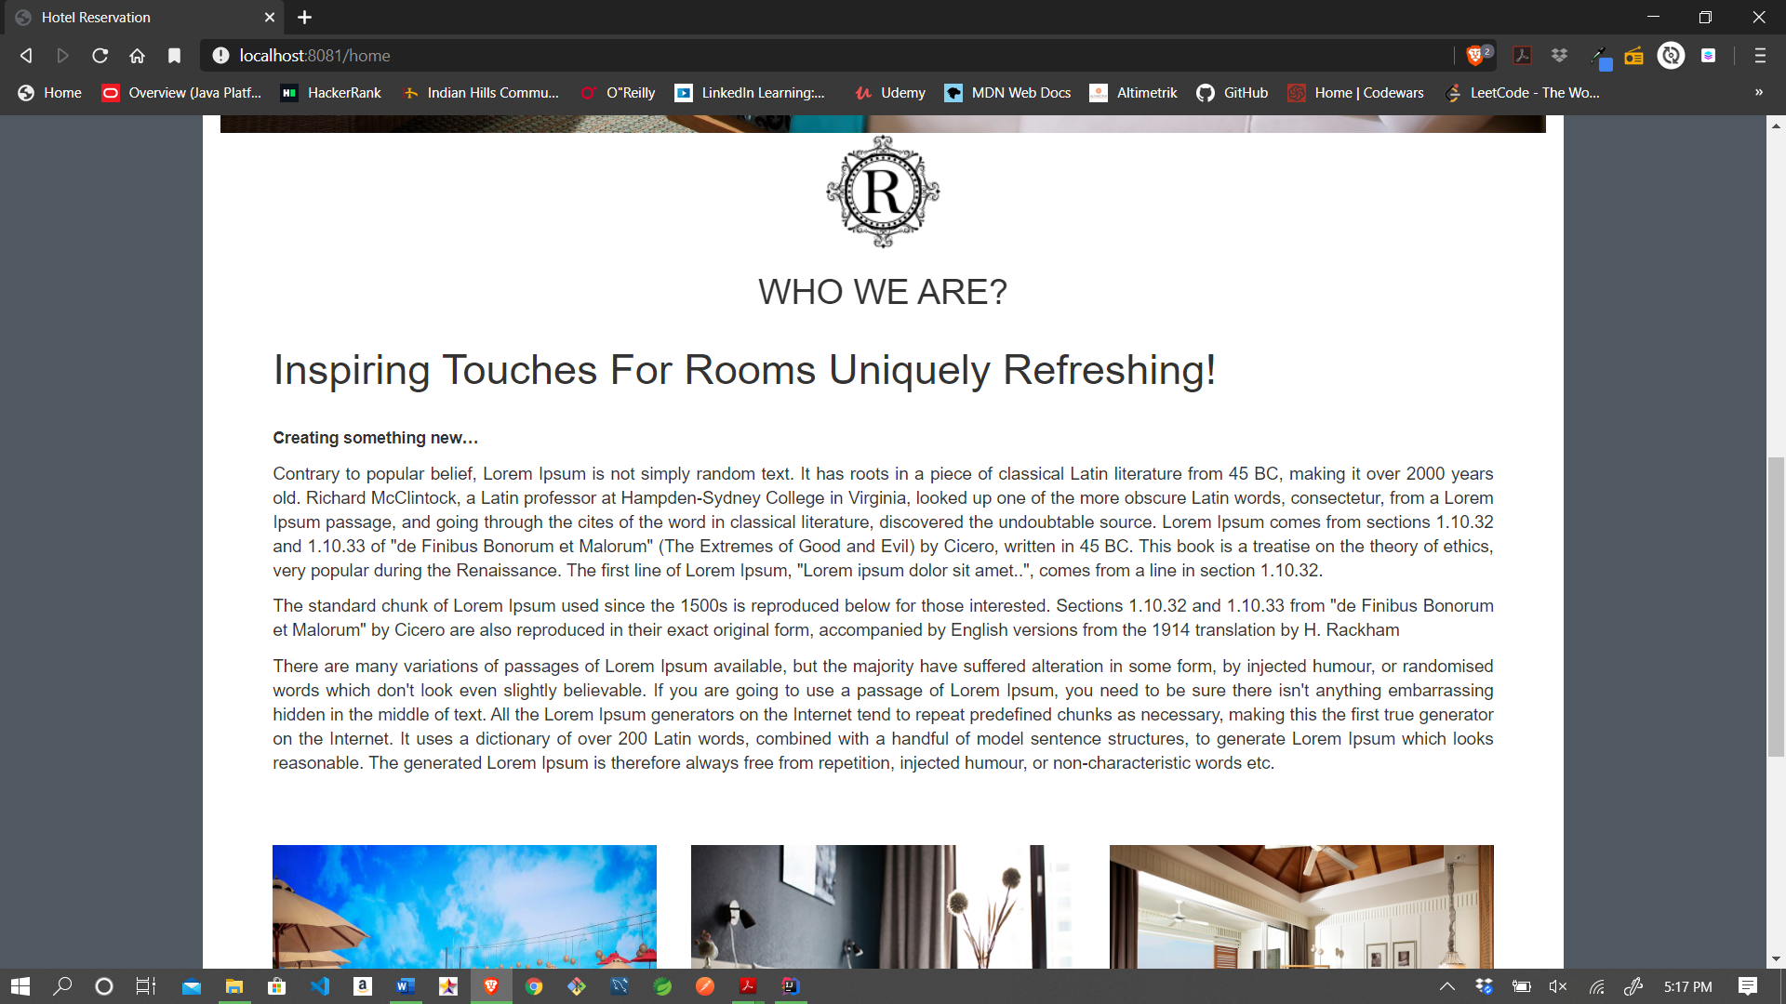

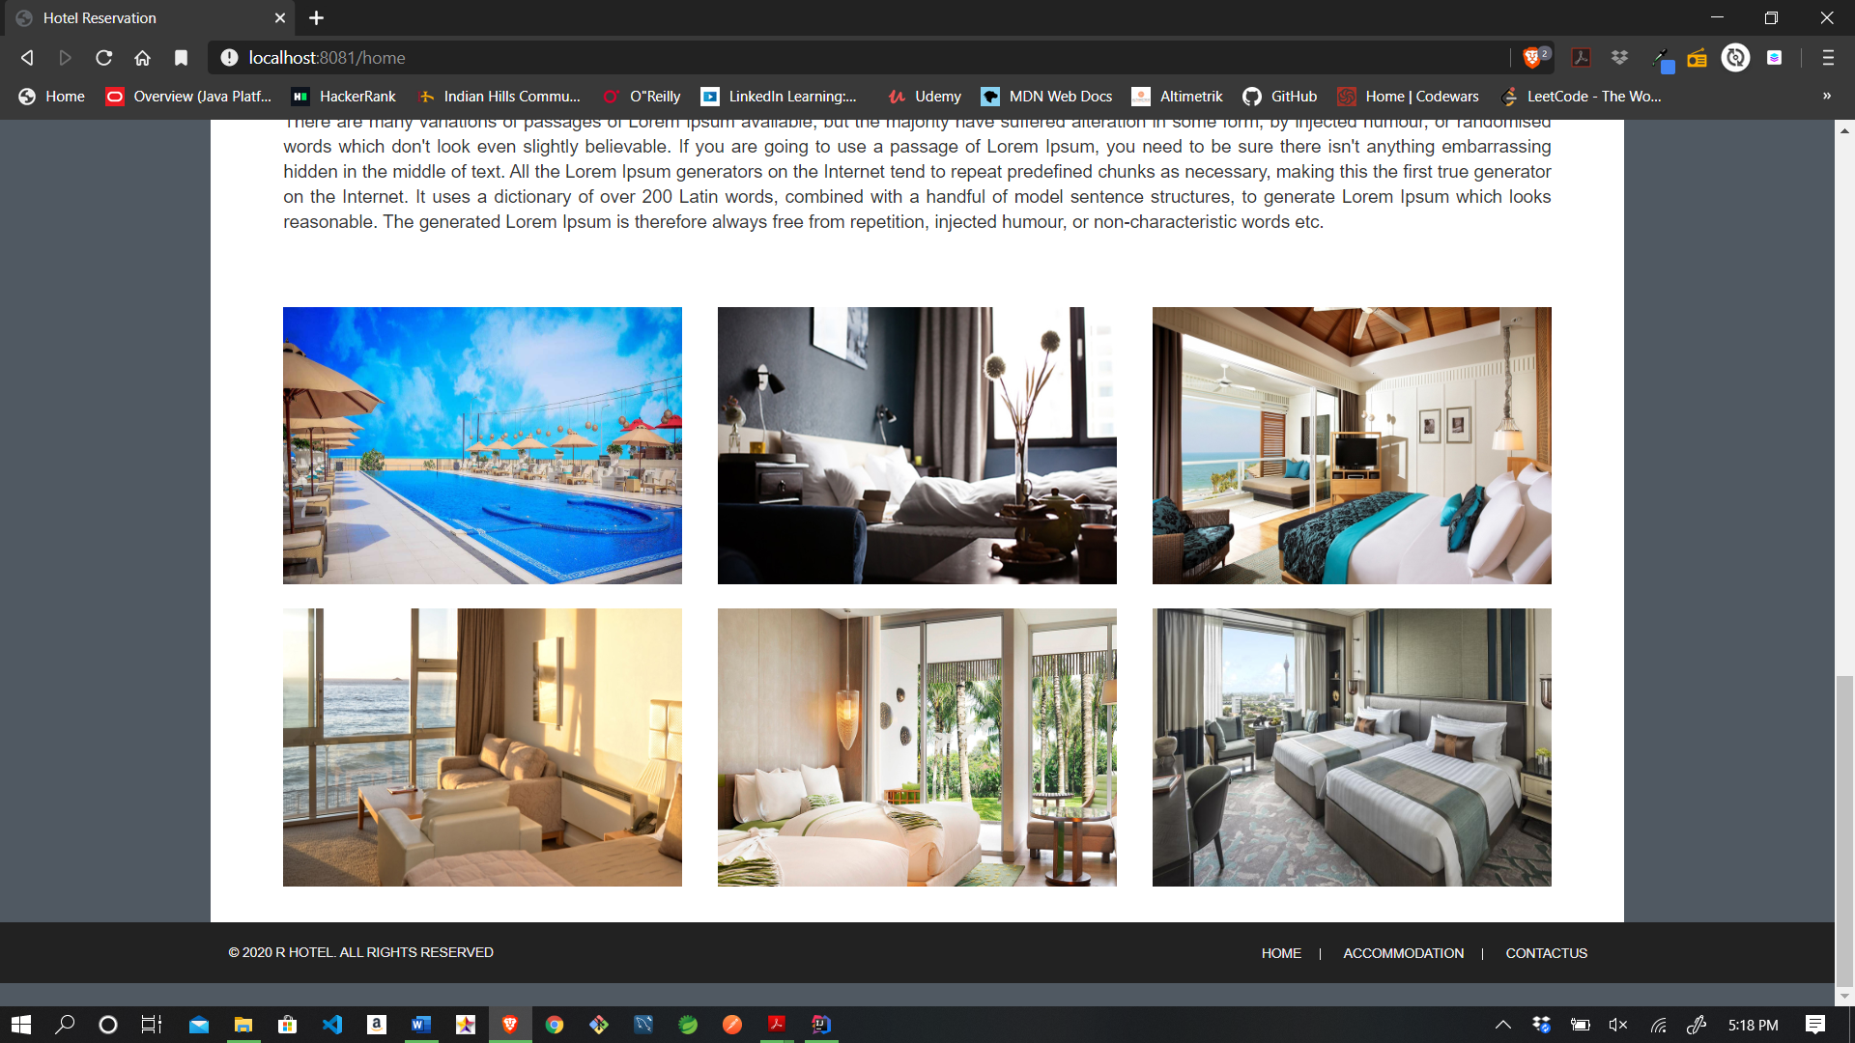

6.7.2 Registration Page

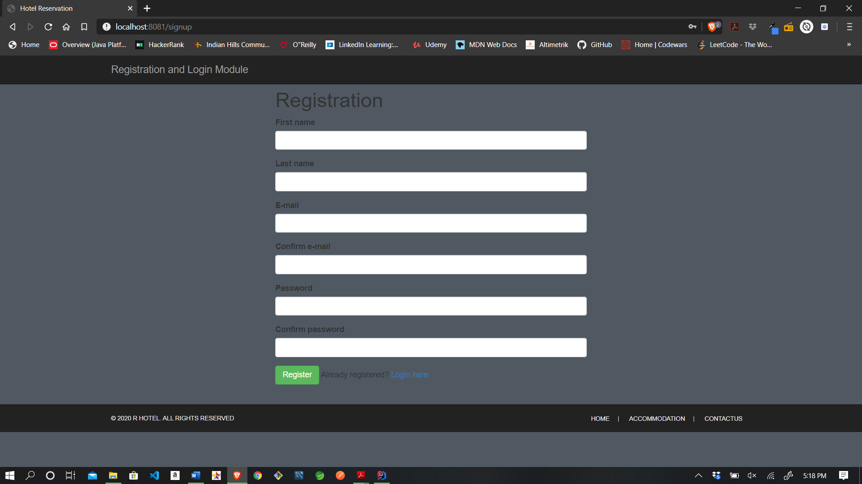

6.7.3 Login Page

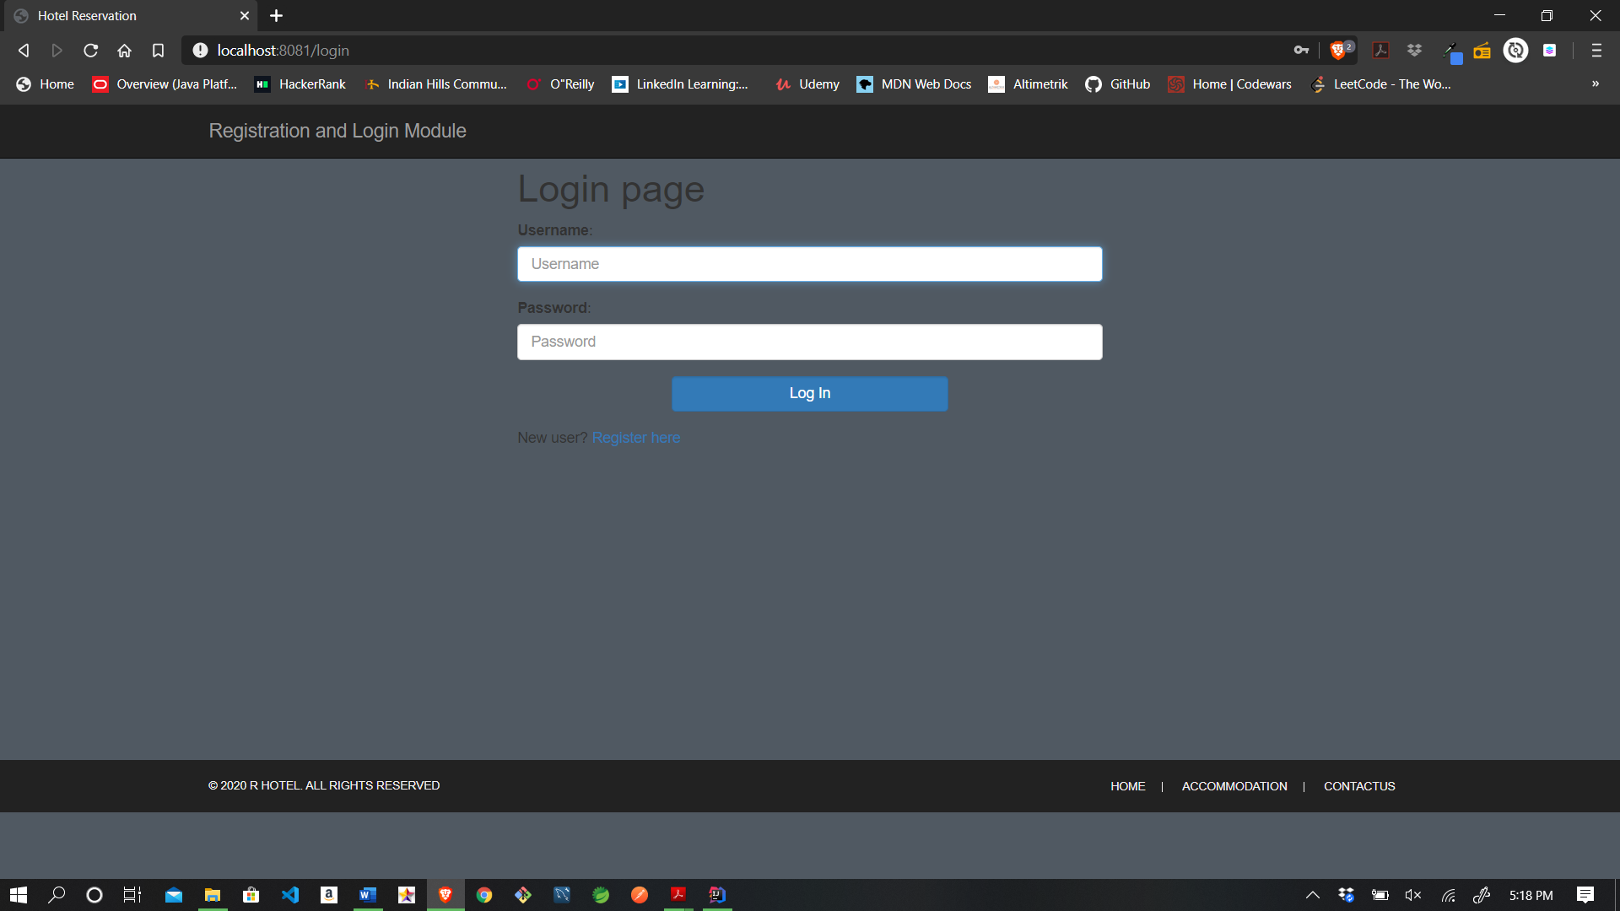

6.7.4 Guest View

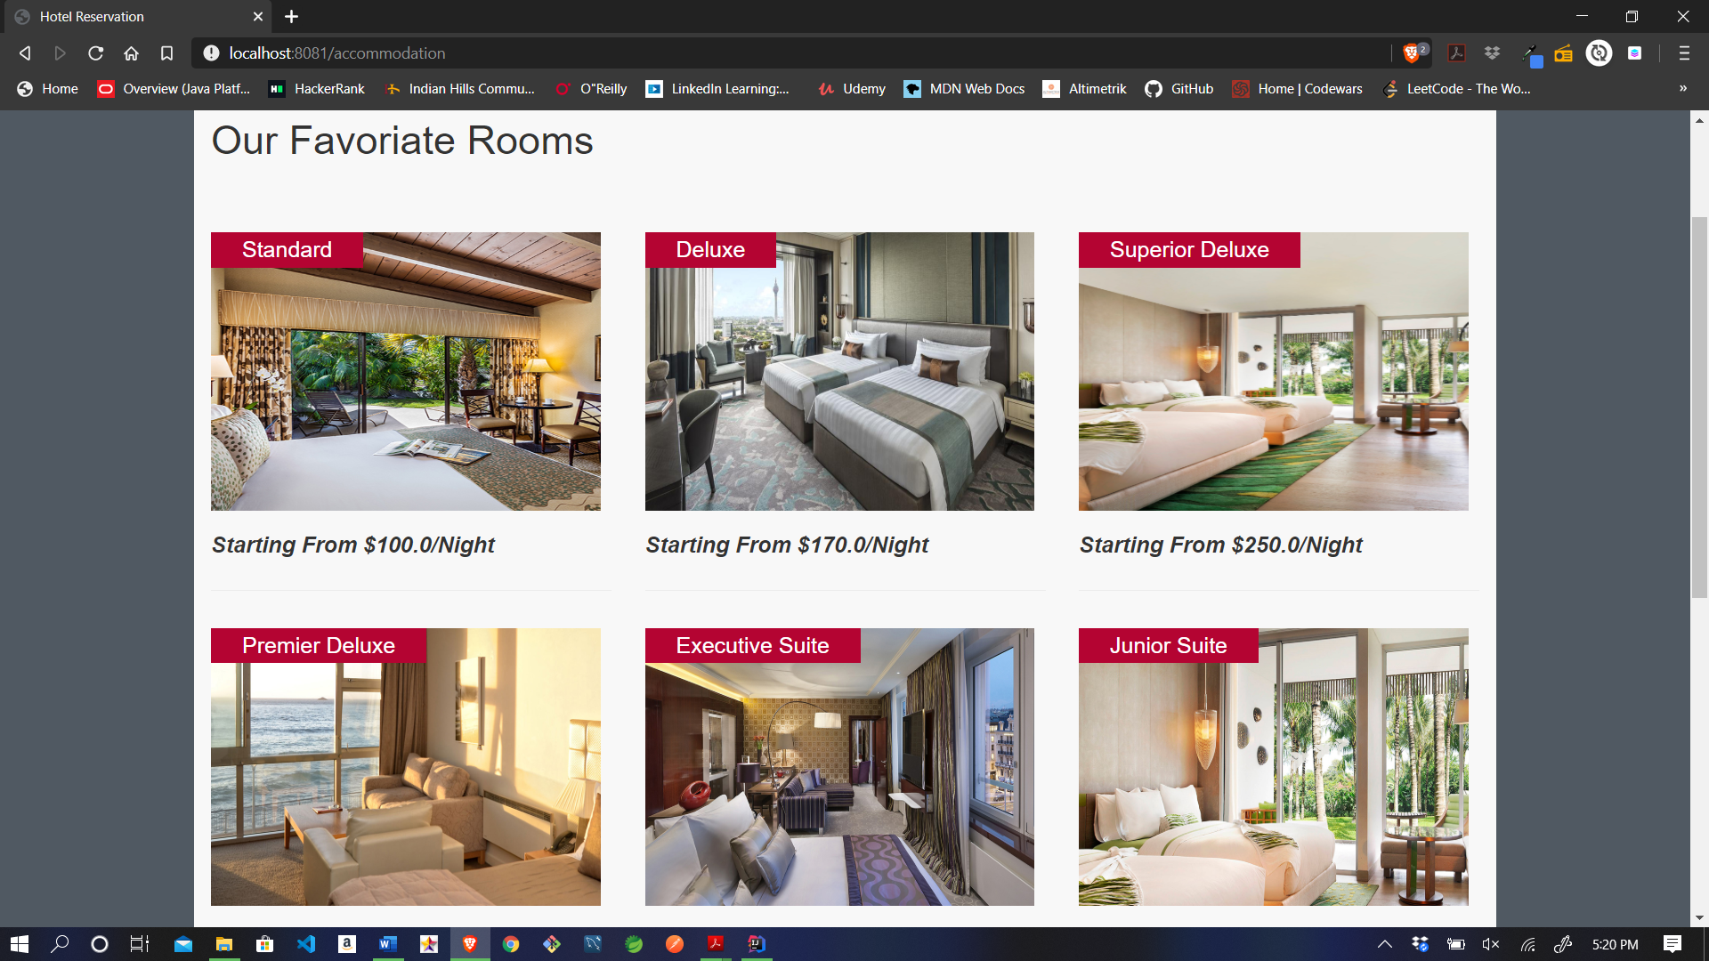

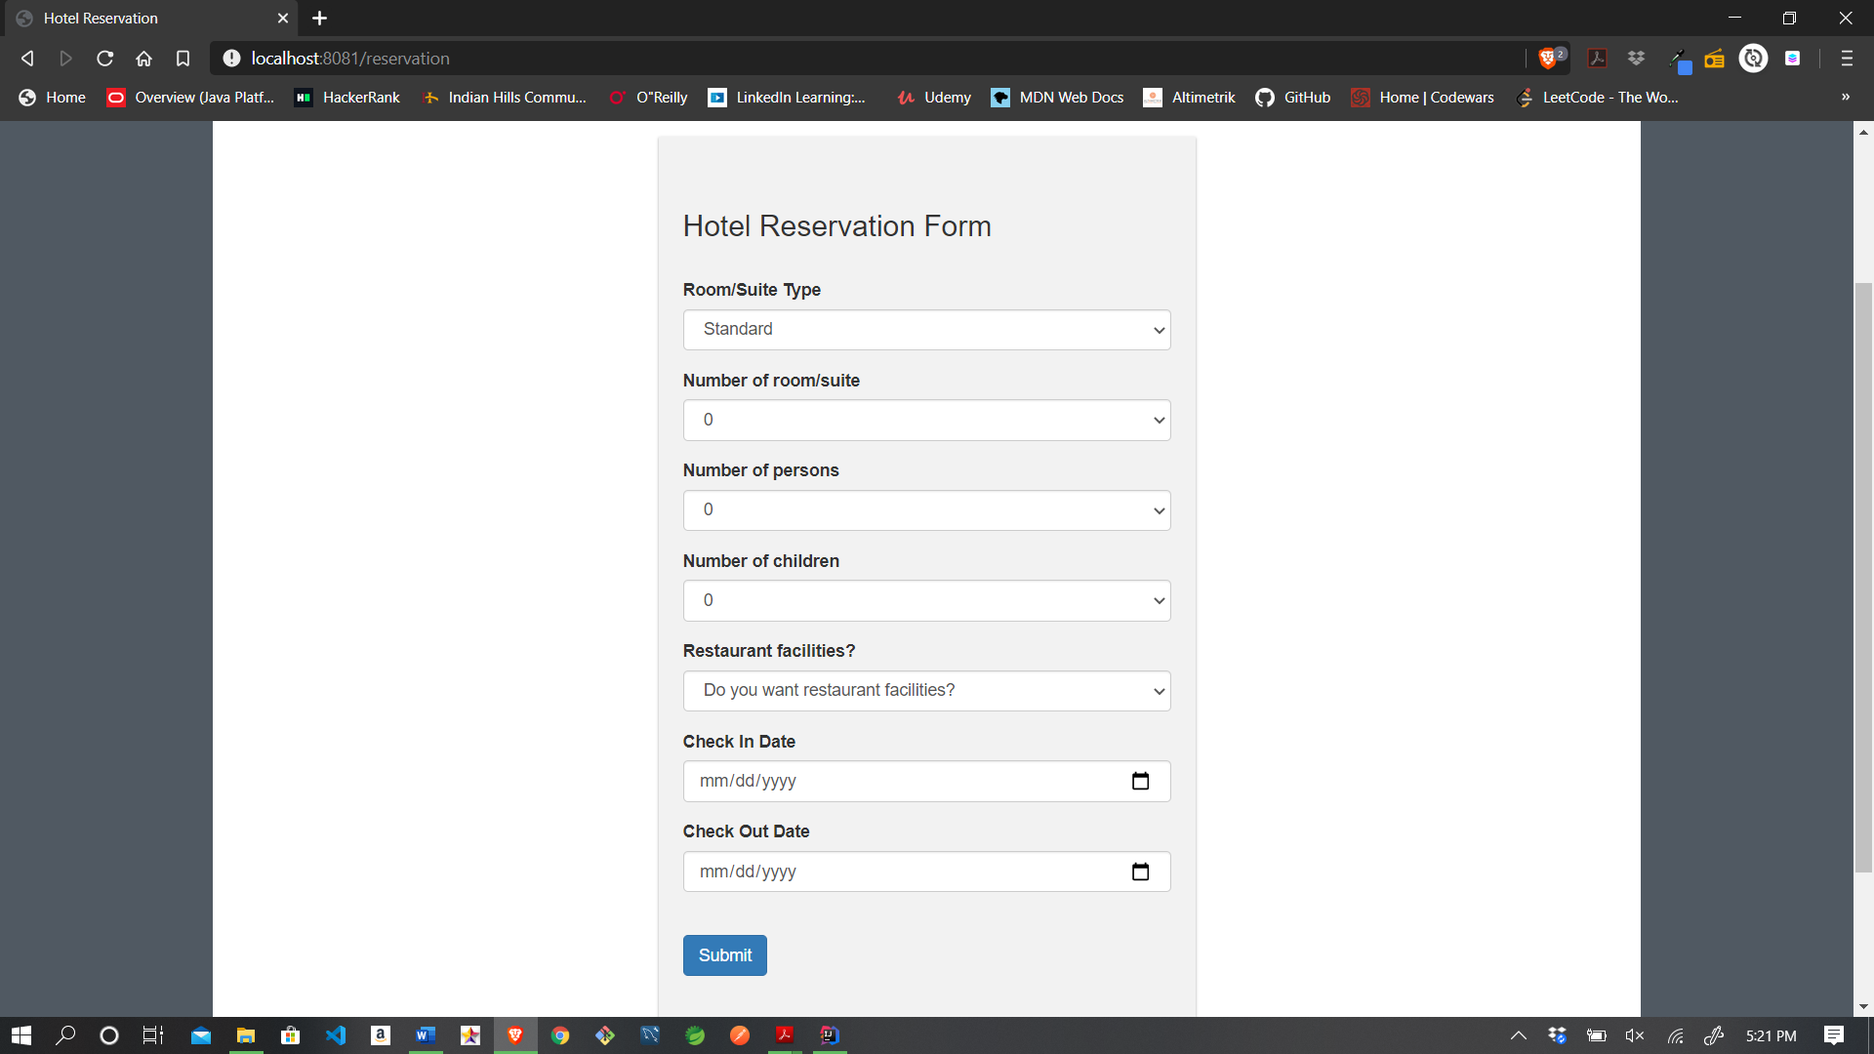

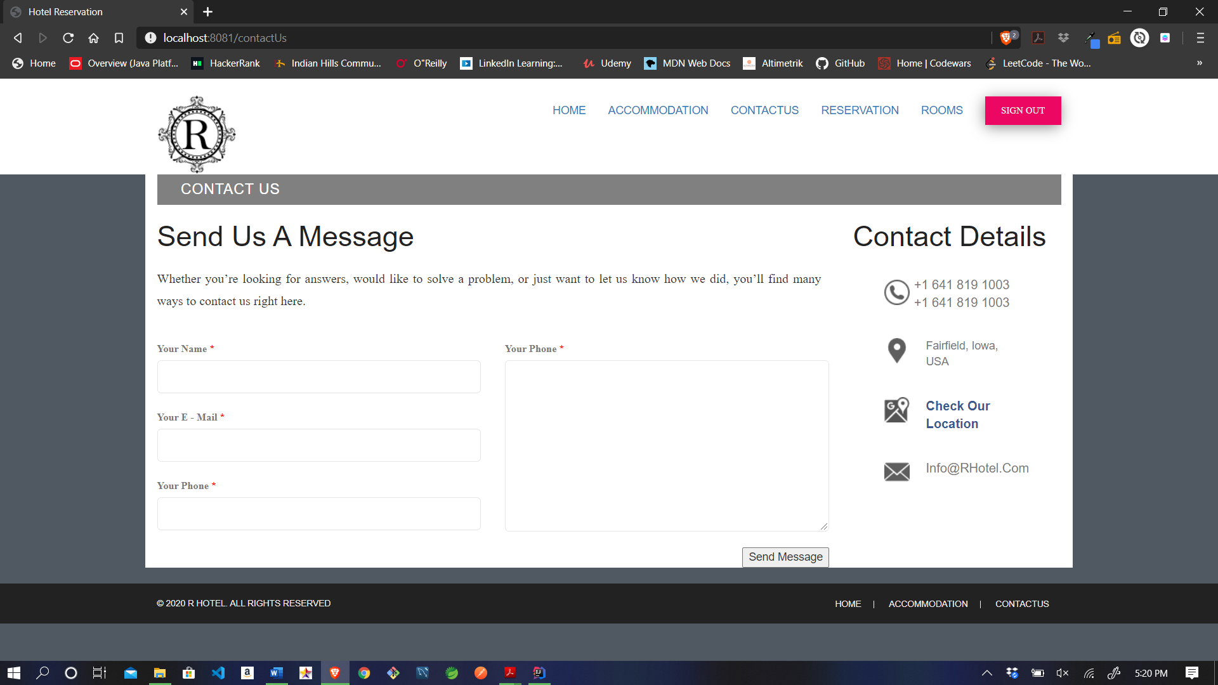

6.7.5 Administrative View

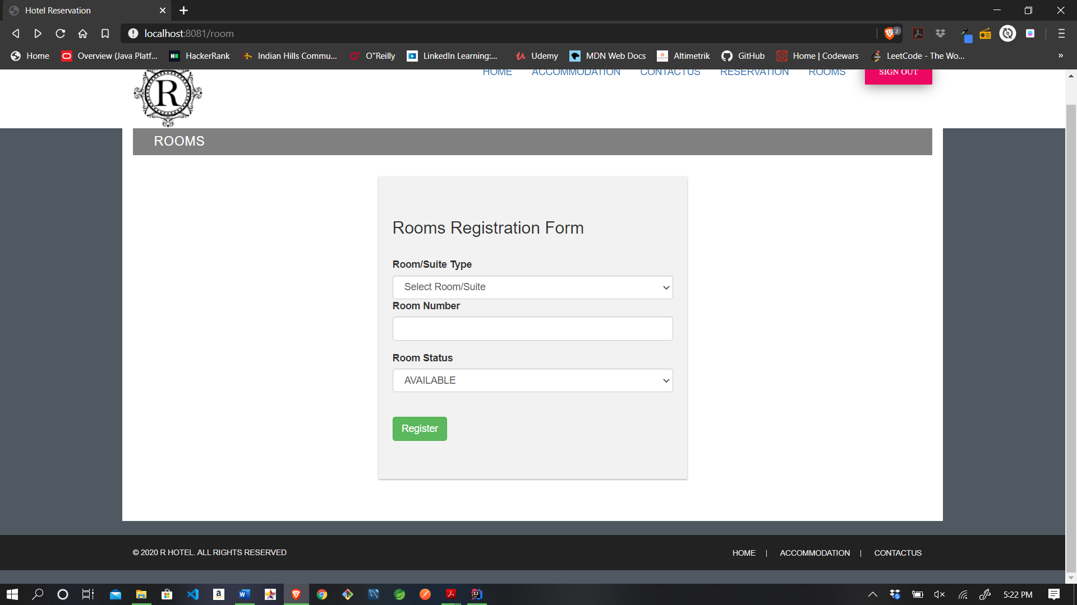

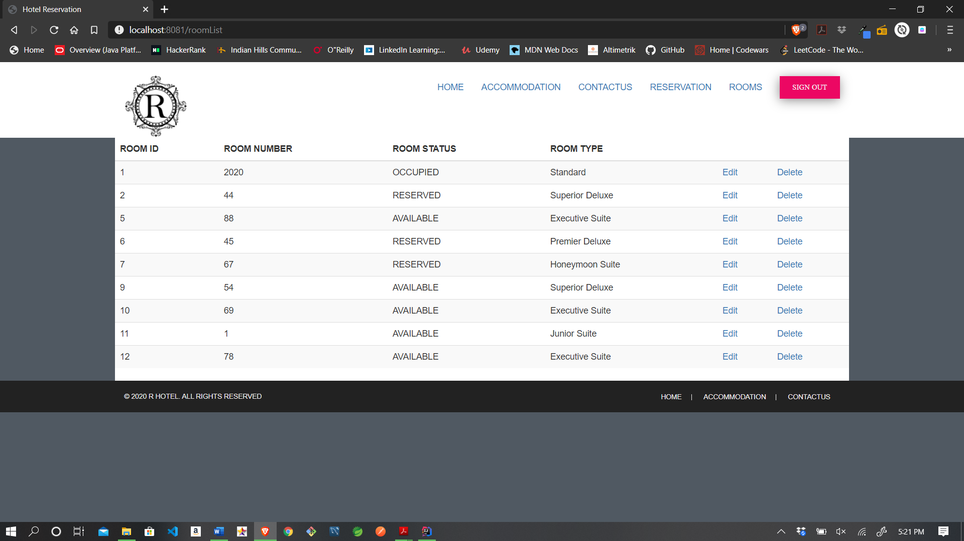

6.7.6 Receptionist View

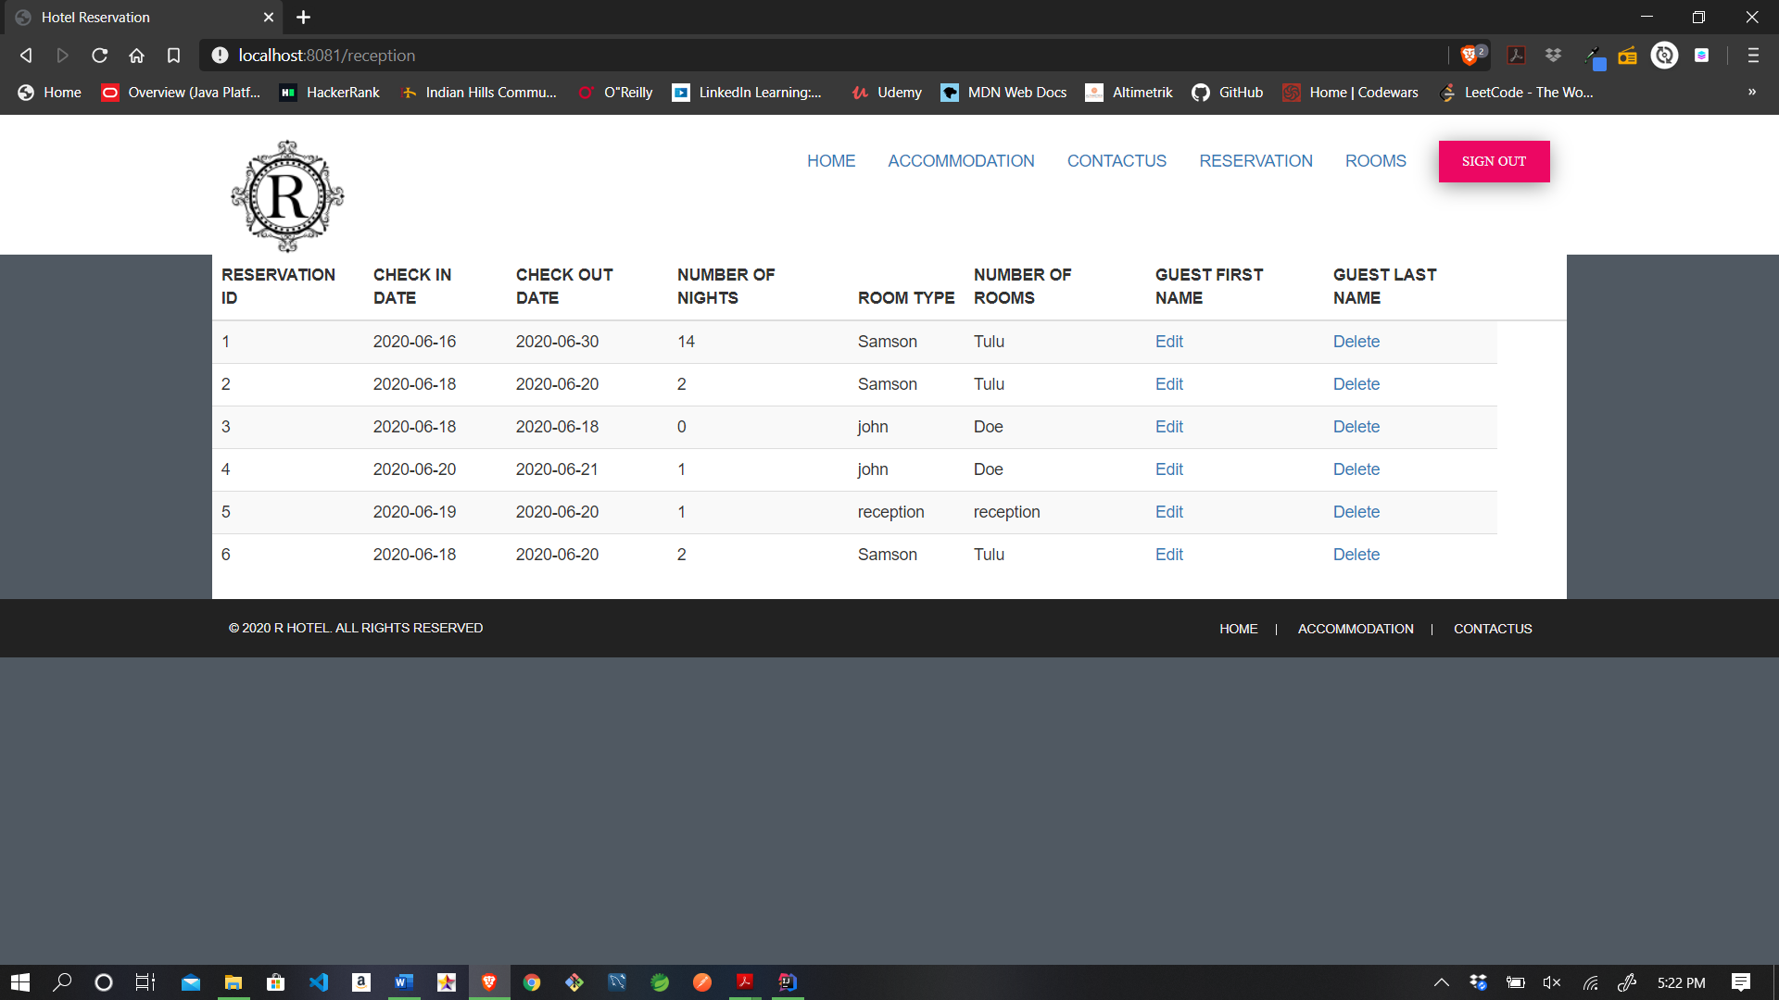

**7. Conclusion**

The entire project has been developed and deployed as per the requirements given, it is found to be bug free as per the testing standards that are implemented. Any specification untraced errors will be concentrated in the coming versions, which are planned to be developed in near future. For this project there are multiple technologies used including Spring Framework, MYSQL database management system, HTML, CSS, Thymeleaf, Lombok and other more.

The system at present does not take care of the money payment methods, as the

consolidated constructs need other standards and are critically to be initiated in the next phase.

The system needs more elaborative technicality for its inception and evolution.

**8. Acknowledgements:**

I have taken efforts in this project from start to completion. However, I would like to express my gratitude towards my Professor Mr. Obina Kalu, for his guidance and constant supervision as well as for providing necessary knowledge and information regarding the project and throughout the course.